Financial Lit Name: _______________________

______________ _____________

WS Assessment

Target 9:

Credit cards

**I can:**

* Compute an average daily balance
* To identify and use the various entries in a credit card statement.
* Calculate the finance charge using the credit calendar.

**Unit 4 Math Topics:**

* Cubic regression
* Exponential growth and decay
* Linear equations and inequalities
* Linear regression
* Measures of central tendency
* Natural logarithm, base e
* Percent
* Quadratic regression
* Spreadsheets and formulas

Consumers enjoy many advantages when using a credit card.

• There is no need to carry large sums of cash.

• Responsible use of a card helps a credit rating (FICO score).

• Customers receive or have access to a written record of all purchases.

• Some cards have rewards programs such as frequent flyer miles.

There are two types of credit card accounts. The most commonly used is the **revolving charge account**. This means that the entire bill does not have to be paid in full each month. There is a minimum monthly payment, and there is a finance charge the month following any month the bill is not paid in full. Customers have the convenience of stretching out payments over as many months as they choose. However, the interest costs for doing this are relatively high. Popular revolving charge accounts include Visa, MasterCard, American Express, and Discover Card.

A **charge card** is a special type of credit card. It allows the cardholder to make purchases in places that accept the card. The monthly bill for all purchases must be paid in full. There is no interest charged.

Popular charge cards used today include Diner’s Club and certain types of American Express cards. Most people informally use the words charge card and credit card interchangeably.

“A **debit card** is not a credit or charge card, because there is no creditor extending credit. If you open a debit account, you deposit money into your account, and the debit card acts like an electronic check”

Credit card companies issue a monthly statement, therefore APR (annual percentage rate) must be converted to a monthly percentage rate. If the APR is 21.6%, what is the monthly interest rate?

Rebecca did not pay last month’s credit card bill in full. Below a list of Rebecca’s daily balances for her last billing cycle.

For seven days she owed $456.11 For three days she owed $1,177.60

For six days she owed $990.08 For nine days she owed $2,115.15

For five days show owed $2,309.13

Find Rebecca’s average daily balance.

Rebecca then must pay a finance charge on her average daily balance. If her card APR is 18%. What is her finance charge for this billing cycle?

Ralph just received his June FlashCard bill. He did not pay his May bill in full, so his June bill shows a previous balance and a finance charge. The average daily balance is $470, and the monthly periodic

rate is 1.5%. What should Ralph’s finance charge be?

Naoko has these daily balances on his credit card for September’s billing period. He paid his balance from the August billing in full.

two days @ $99.78 fifteen days @ $315.64 eleven days @ $515.64 two days @ $580.32

His APR is 15.4%. How much is the finance charge on his September bill?

Does the credit card company need to calculate his average daily balance? Explain.

Naoko calculated his average daily balance to be $377.85. Is he correct? If not, what was his average daily balance?

At the end of a billing cycle, the credit card company takes an accounting of your credits and debits and sends you that information in the form of a **credit card statement**. You should read the statement carefully and verify the charges. All credit card companies have a process through which the credit card holder can dispute errors on the statement.

Use the sample statement to answer.

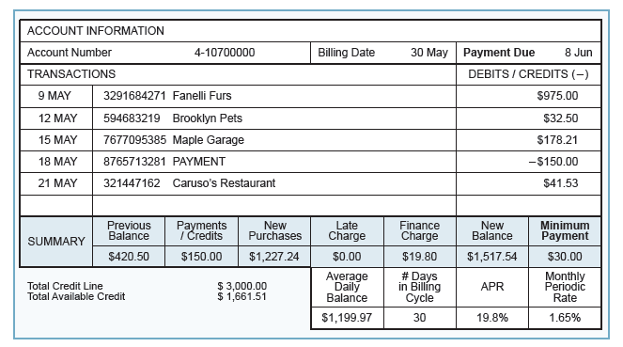

How many purchases were made during the billing cycle?

What is the sum of all purchases made during the billing cycle?

When is the payment for this statement due?

What is the minimum amount that can be paid?

How many days are in the billing cycle?

What is the previous balance?

Fill in the missing amounts for a 🡪 d

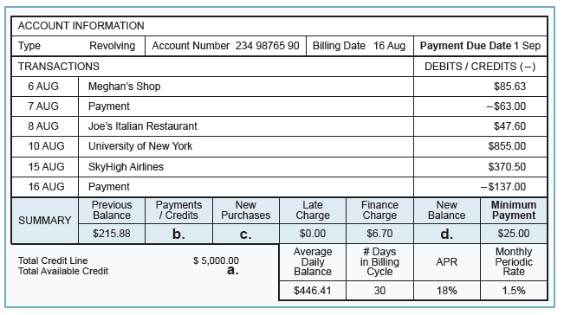

a =

b =

c =

d =

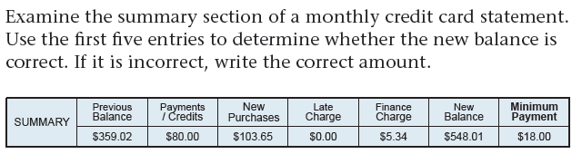

Calculate the average daily balance using a credit card billing calendar, often called a **credit calendar**.

Verify the average daily balance of this statement

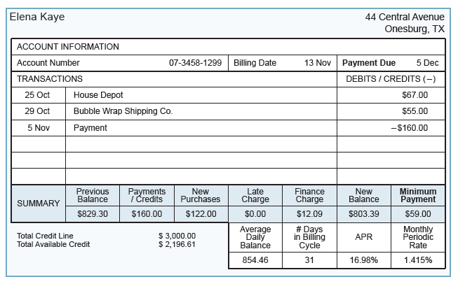

Use the 7 x 5 box

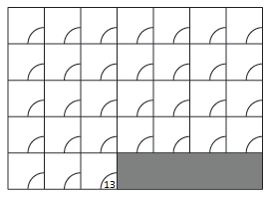

26,488.30 ÷ 31 = 854.46

Now verify the finance charge on the statement

Given the statement as follow

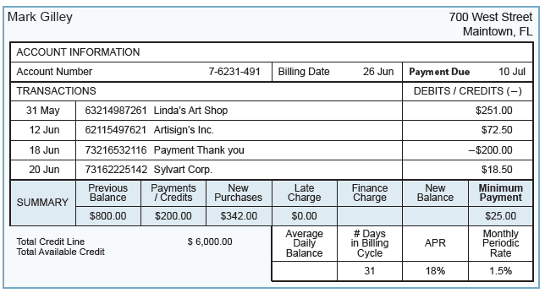

What is average daily balance?

Finance charge?

New balance?

Available credit?

e. If the $200 payment had been posted on 6/13, would finance charge for this billing cycle have been higher or lower?

**Assessment Target 9**

**I can…** calculate average daily balance and finance charge

Lauren did not pay her January FlashCard bill in full, so her February bill has a finance charge added on. The average daily balance is $510.44, and the monthly periodic rate is 2.5%. What should

Lauren’s finance charge be on her February statement?

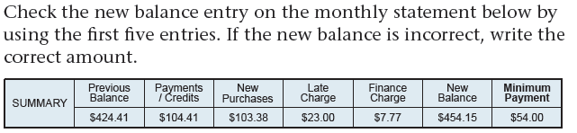

Given the statement as follow

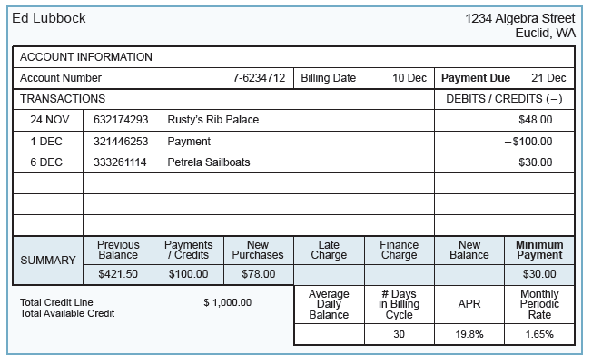

What is average daily balance? Finance charge? New balance? Available credit?

If the $30 charge to Petrela Sailboats had been posted on 12/9, would the finance charge be higher or lower for this billing cycle? Explain